Corrections to the website:
- Please change the call now no to 886 191 9000
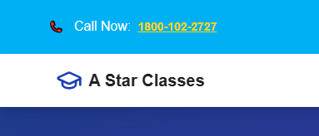

- Pay Due fee is going to the Aakash tuitions page. Please delink!

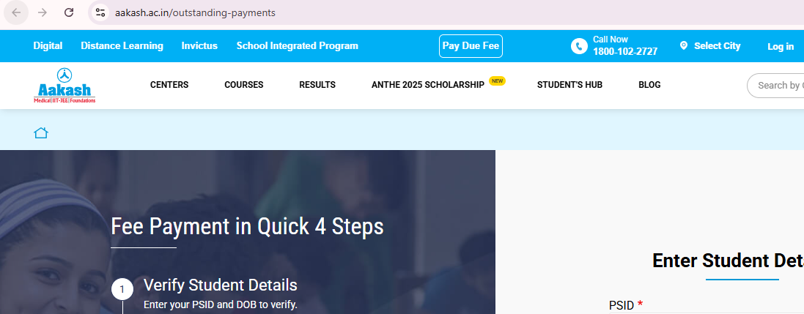

- Schedule a demo and whatsapp is going to a wrong no. It should go to 886 191 9000
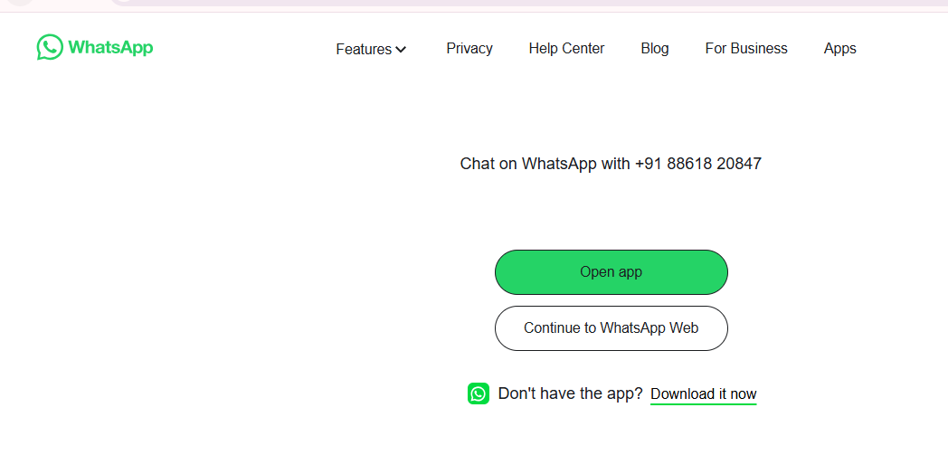
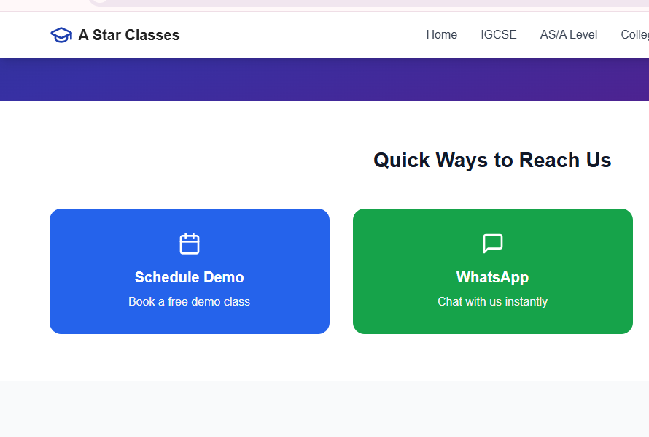

- The contact no and email id needs to be changed. Contact no. : +91 886 191 9000 and email id: astarclasses@ixpoe.com. Location can be Bangalore, Karnataka, India

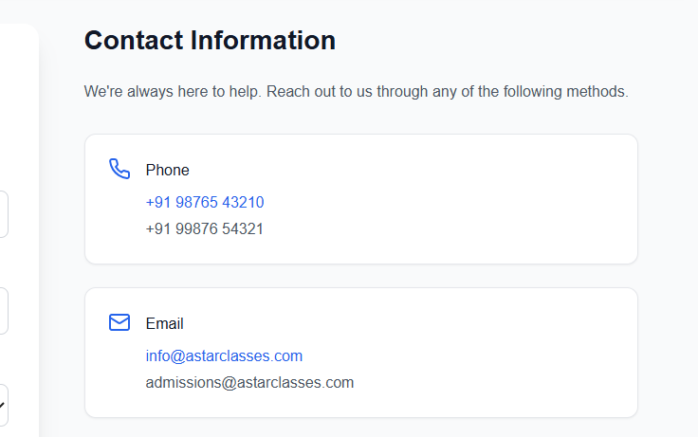
- These are not part of A Star offerings. Kindly delete these courses.
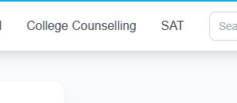
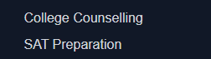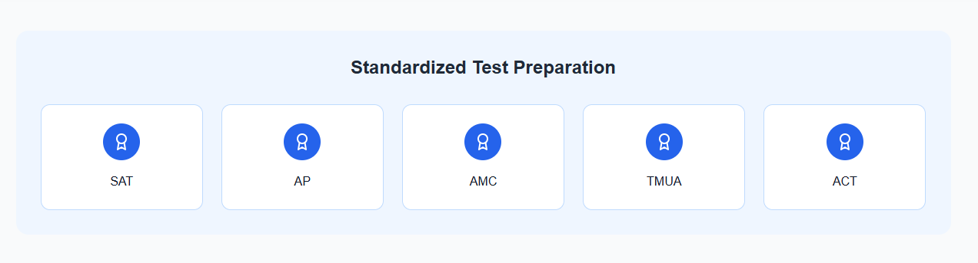
- AS and A levels are merged together and the topics taught under these boards are put altogether in the files. I think there should be separate link for AS and A levels. As per our website document, you can see that AS and A levels has different topics which are covered under them.
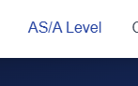
- Under IGCSE and AS/A levels subjects, only the topics (Cell Structure, Biological Molecules, Enzymes, …..) are added. There are subtopics under these topics too which are provided in the website document. I think those needs to be added too once the topics are expanded.
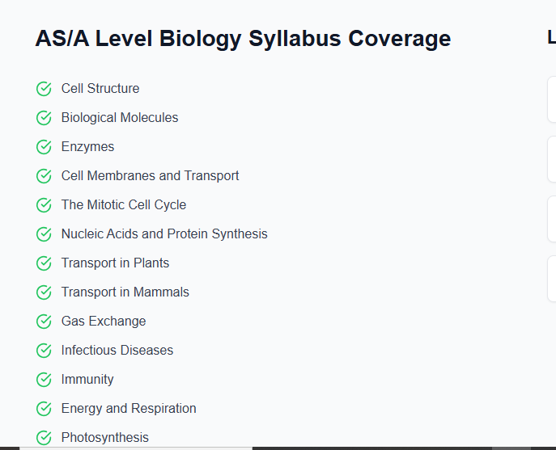
- The tutor’s profiles are not added or cannot be seen. Please add the section for the same.
- Did not see the A star logo anywhere on the website. Please add the logo wherever applicable as per the design and requirement.

